Part 1 – Install MongoDB

1. Go to http://www.mongodb.org/ (not http://www.mongodb.com) and download the latest version of MongoDB. Unzip it in an executable directory – typically: c:\mongodb\program

2. To make working with MongoDB easier, add this folder to your path. Need some help? Look here.

3. You should see the following files:

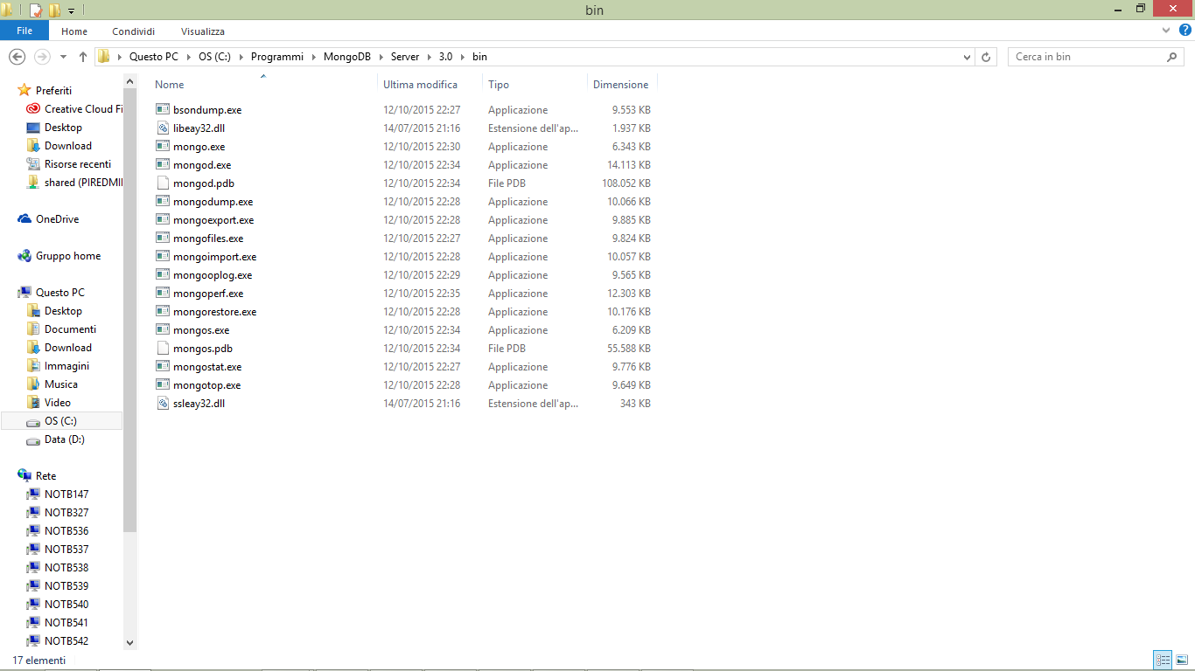

1. Create a directory where mongodb should store its data files, for example: C:\MongoDB\mongodata
2. Create a directory where mongodb should store its log files, for example: C:\ MongoDB\log
3. Our goal is to install MongoDB as a Windows Service. But it is much easier to debug setup issues in the command prompt. Try starting mongod.exe in the command prompt using this command (altered for an path changes you chose):

C:\Programmi\MongoDb\Server\3.0\bin\mongod.exe –dbpath C:\mongodata

(depending by the path where Mongo is installed)

1. Then start the client, starting mongo.exe in the command prompt using:

C:\Programmi\MongoDb\Server\3.0\bin\mongo.exe